January 2020

The Monthly Newsletter of First Presbyterian Church of Britton SD
Pastor Donald Buck – 605.551.9001; Church 605.448.2460

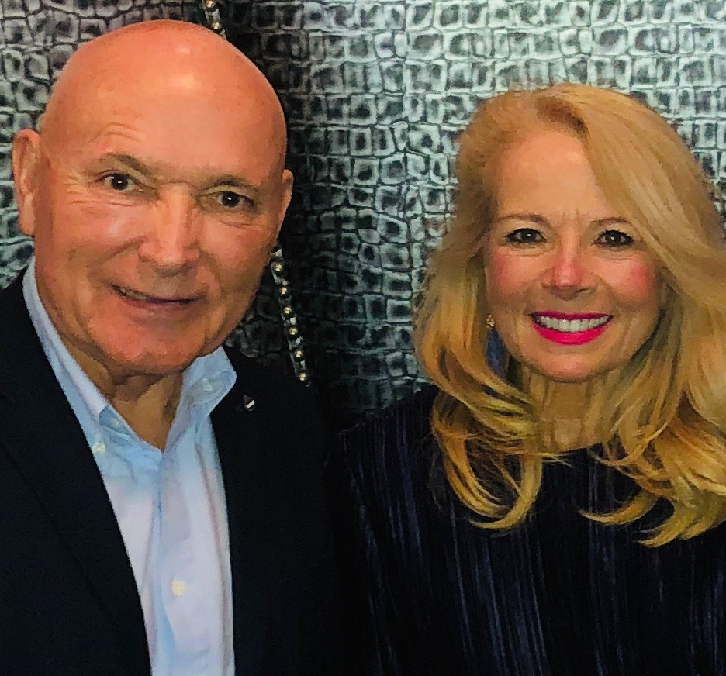
The Bucks’ Blog:
It’s over and it’s just beginning.

Here it is… ready or not… January 2020!
Where did 2019 go? Just when we thought it would never end,
December 31st surprised us, and 2019 was over.

Ready or not… it’s January, 2020… a year like every new year,
a year of choices, doors, and opportunities.

January is named for Janus, the Roman god with two faces…

one looking forward and one looking backward. He is said to have been the first Roman god, the god of all gods.
He was the god of choices, doors, opportunities, etc.
And so we, some 2,000 years later, are presented with an opportunity to start new, to start fresh.
It’s been said that our lives are the sum total of our choices; and that ultimately, if you want to change your life, you must change your choices. Like many of us, being creatures of habit, changing our choices sounds simple in theory and very difficult in practice.
For example: the number one New Year’s resolution, every year, is to lose weight. I read last week that by 2030, 50% of the population of the United States will be clinically obese. So much for following through on the resolution to lose weight.
The second most popular New Year’s resolution is to write a book. With tweeting being the most popular way of communicating and texting following close behind, who will honestly take the time to write a book unless it’s a compilation of a year’s worth of 140-character tweets.
As those of us who are endeavoring, as best we can, to follow the way and teachings of Jesus, a New Year can present a “Resolution Anxiety”. Seeing that a New Year follows hard on the heels of our celebration of the birth of Jesus (God becoming human in every way), we Christians are sensitive to choices made in the past year that have not produced the desired outcome. We realize we haven’t read our Bible as much as we intended. We realize we haven’t prayed as authentically as we desired. And we realize our lives, instead of coming closer to Christ Jesus, have drifted from Him… somewhat.
And so, we resolve, usually, at this time of year to do better and to change all of that. Meaning we will resolve to pray more, read our Bible more, and get closer to Jesus.
In the words of the television psychologist, Dr. Phil, how’s that been working out for you… in previous New Year’s resolutions?
Our resolve is firm, our intentions are good, and our hearts are pure; yet, our follow through is pitiful.
I can hear some of you saying about now, “Oh, thank you Pastor. Thank you for dumping a load of negative reality on me after a totally frazzled and exhausting Christmas season.”
I have good news for you!
First, I love you. I love you all with the love of Jesus.
Second, I accept you just as you are… the best parts and the not-so-best parts.
Third, (and this is a secret, don’t tell anyone) I’m going to tell you how you can follow through on your New Year’s resolutions for the first time in a long time.
Ready? Baby steps. That’s it! Earthshaking isn’t it?? Baby steps.
How does a baby learn to walk? By attempting to take that first step and then another and then another.
What happens… at first, they fall down more than they succeed.
BUT… they get up and start again.
Friends, it’s just that simple, and it’s just that hard.
A Japanese proverb says, “Fall down seven, stand up eight.”
No matter how many times you forget to do your resolution, don’t quit. Keep pressing on… don’t allow anyone to pour a guilt trip on you. Instead, forget about the past, and start again.
And little by little, you’ll see that New Year’s resolution come into reality.
Friends, it’s not about how you start, it’s about how you finish.
Put your Bible out where you can see it. Start by reading one verse or two. As you go along in your day, whisper a prayer of joyful thanksgiving to Jesus for his love, acceptance, and forgiveness of your sin penalty. Go to church one Sunday. Of course, you’re going to see hypocrites there (And they’re usually the ones doing the judging of others. But pay them no mind… let God deal with ’em).
Just go to church for the good you will get from the singing and the presence of God in Christ by the Holy Spirit.
When you do this consistently, your life will be different at the start of 2021… I promise.
Let me know how it’s going… I’d love to hear about it!
Donald and Mindi



Prayer for a Happy New Year
May the Lord make my New Year a happy one…
Not by shielding me from sorrow and pain, but by strengthening me to bear it if it comes.
Not by making my path easy, but by making me sturdy enough to tread any path.
Not by taking hardship from me, but by taking all cowardice and fear from my heart as I meet hardships.
Not by granting me unbroken sunshine, but by keeping my face bright even in the shadows.
Not by making my life always pleasant, but by showing me where men and His cause need me most and by making me zealous to be there and to help …
God, make my year a happy one.
—Guideposts magazine (January 1973)



God's Will in the New Year
Father, I abandon myself into your hands.
Do with me whatever you will.
Whatever you may do, I thank you.
I am ready for all, I accept all.
Let only your will be done in me, and in all your creatures.
Into your hands I commend my spirit.
I offer it to you with all the love that is in my heart.
For I love you, Lord, and so want to give myself,
to surrender myself into your hands,
without reserve and with boundless confidence,
for you are my Father. Amen.
—Charles de Foucauld, 1858-1916

Comfort for the New Year
Heavenly Father,
At midnight,
When the old year dies,
And the new comes bounding in,
I draw strength from knowing
That in the next twelve months
The snows will go
The buds will burst
The heat will rise
The leaves will fly,
That all these things will happen
According to Your schedule
And in Your time;
That there is order in Your universe,
And that I am part of it.
—Van Varner, longtime GUIDEPOSTS editor and former editor-in-chief

Credo for the New Year
I believe
That I enter a glorious new year
To be filled with prayer and praise.
With service to God and mankind,
With inspired creative activity.
I believe
That God’s presence goes with me
Wherever I shall go this year,
By train or Ires or car or boat,
Slowly paced on foot, or high in air.
I believe
His love is shining in my body,
His wisdom guides my mind,
His peace fills me with poise,
His strength is ever at my call.
Oh I believe
That this is God’s new year.
—Elizabeth Searle Lamb


Group # 5 is the serving group this month. This group consists of:
Jan Pearson, leader 448.5653, cell: 448.8164; Kathy Buisker, Patti Niesen, Brenda Johnson, Jane Tyler and Carol Anderson.

Ladies’ Sewing Group will meet on January 16th, 23rd and 30th this month.

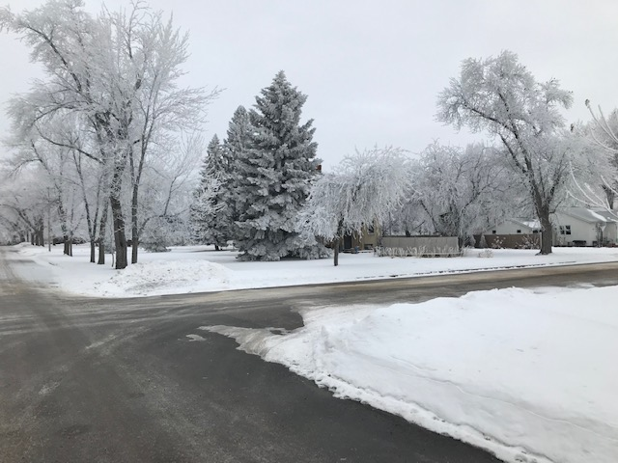

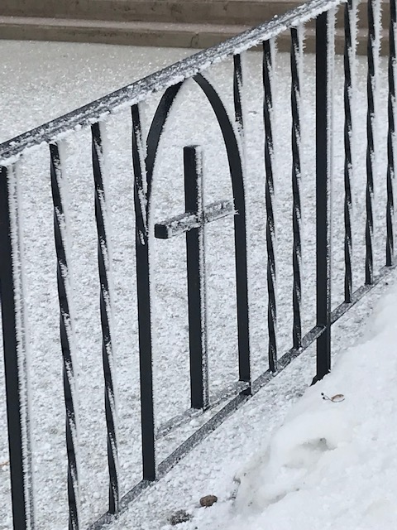

God’s Beautiful Gift to us
on Christmas Day



Session Notes:
- 1. Approved the Paul Symens family to use the church for a family reunion July 11, 2020.
- 2. Personnel will look into finding someone to clean the church.
- 3. Approved communion for each Sunday in Advent and Christmas Eve.
- 4. Approved communion the first Sunday of each month.
- 5. Approved $4500 for 2020 Local Mission Giving and $10,500 for 2020 Unified Mission Giving.
- 6. Session elected Lynn Eberhart as clerk for 2020.
- 7. Session elected Becky Weber as church treasurer for 2020.
- 8. Appointed Brenda Johnson commissioner to Presbytery.
- 9. Pastor Buck plans to attend General Assembly in Baltimore, MD June 20-27, 2020.

Next meeting of the Session will be Wednesday, January 21st, at 7:00 PM


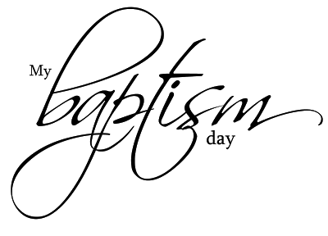

Church Members Celebrate Baptism Blessings with Their Extended Families

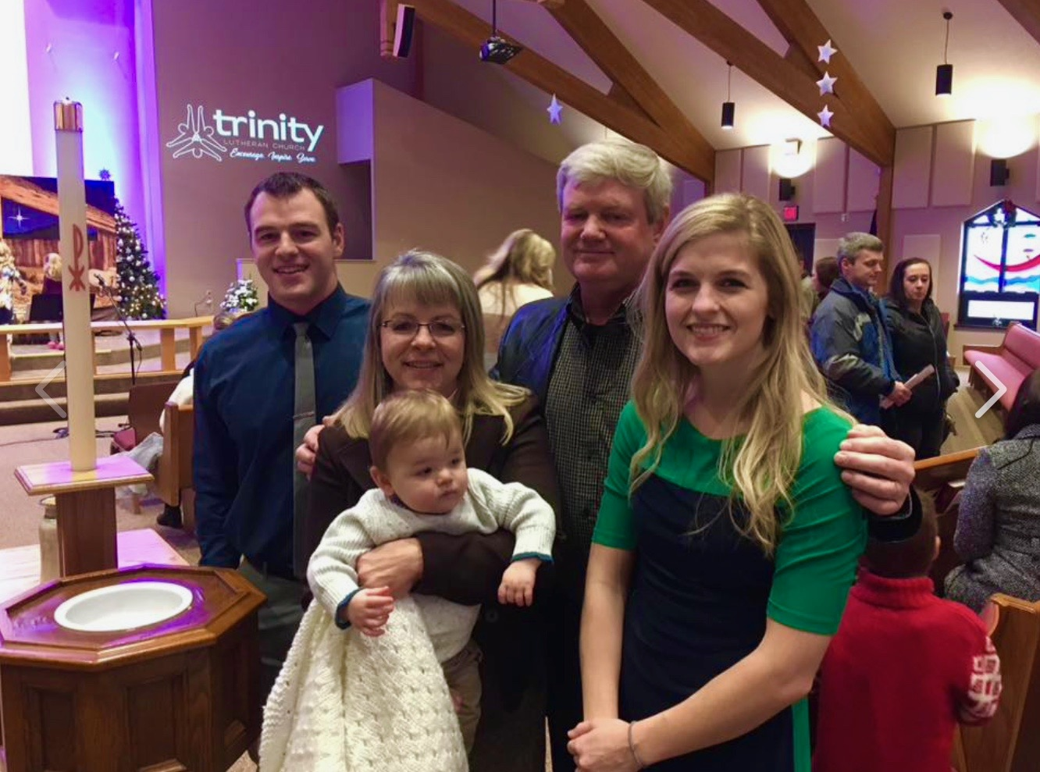
Patty and Kieth Niesen celebrated the baptism of their new grandson, Cade Michael, on Sunday, December 15th, at Trinity Lutheran Church in Sioux Falls. Parents are John and Krystal Niesen.

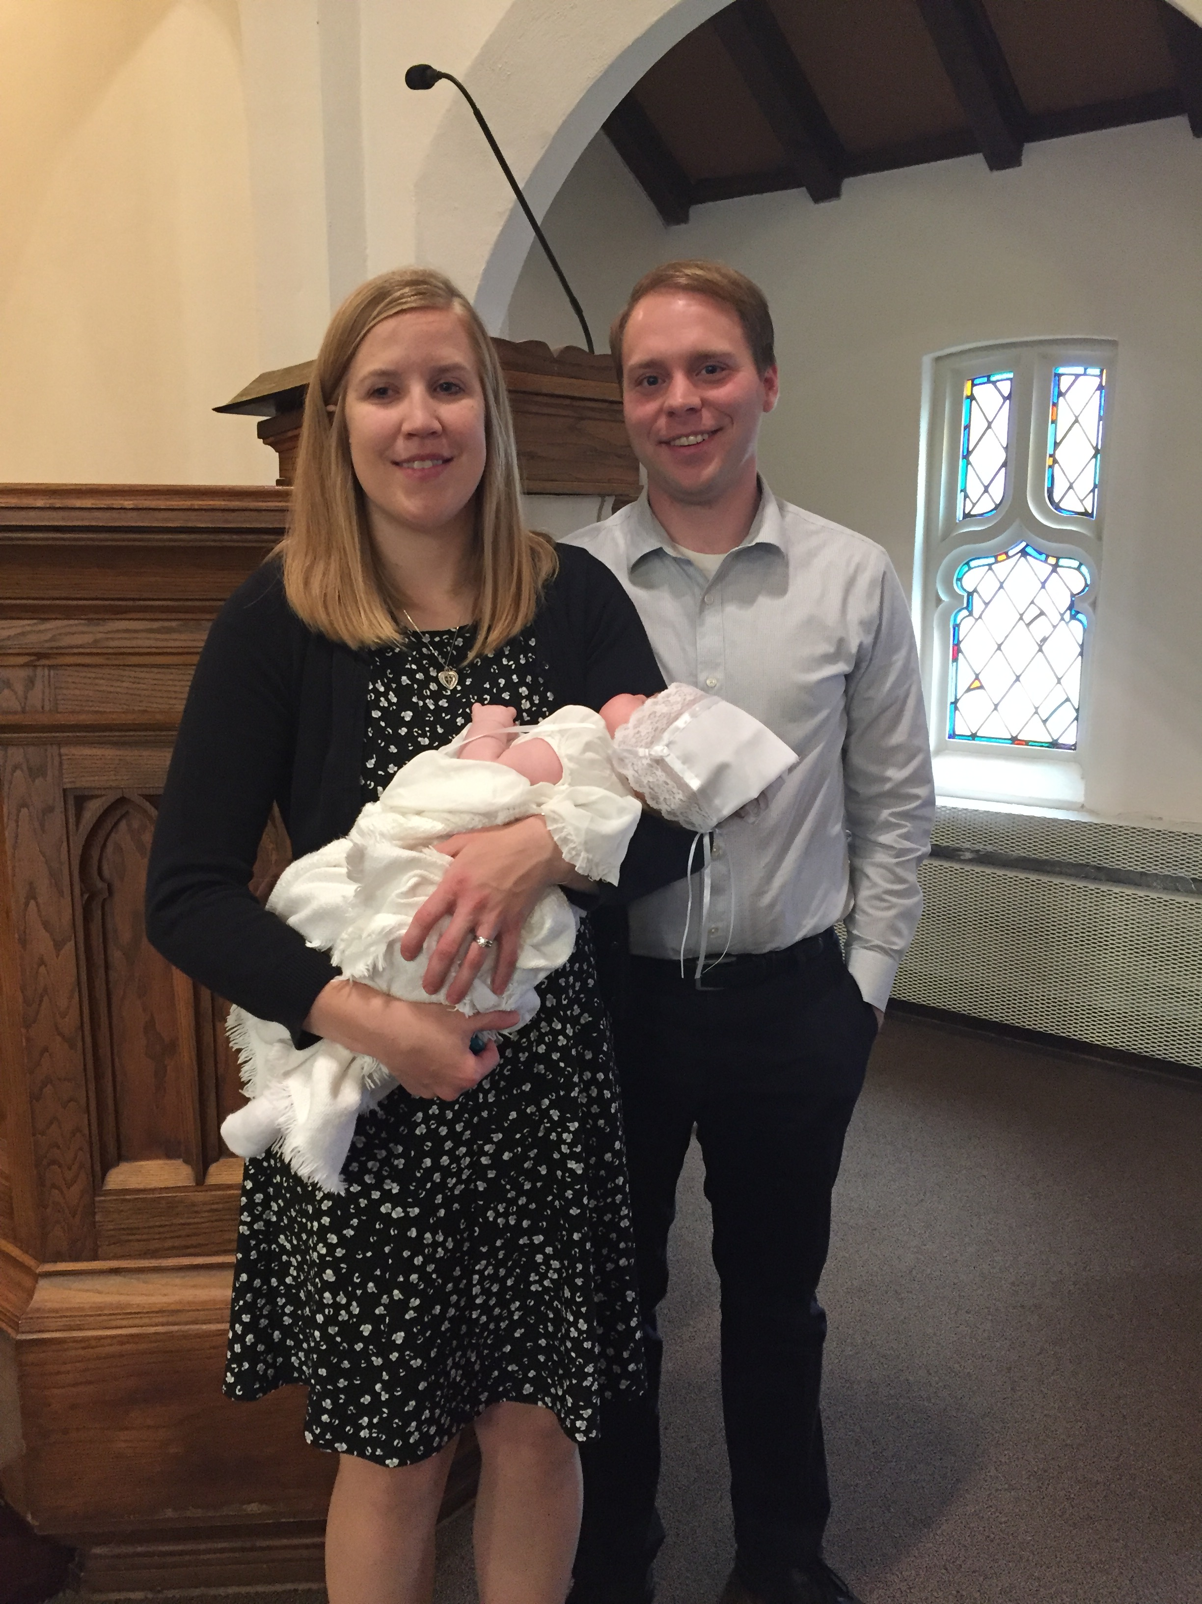
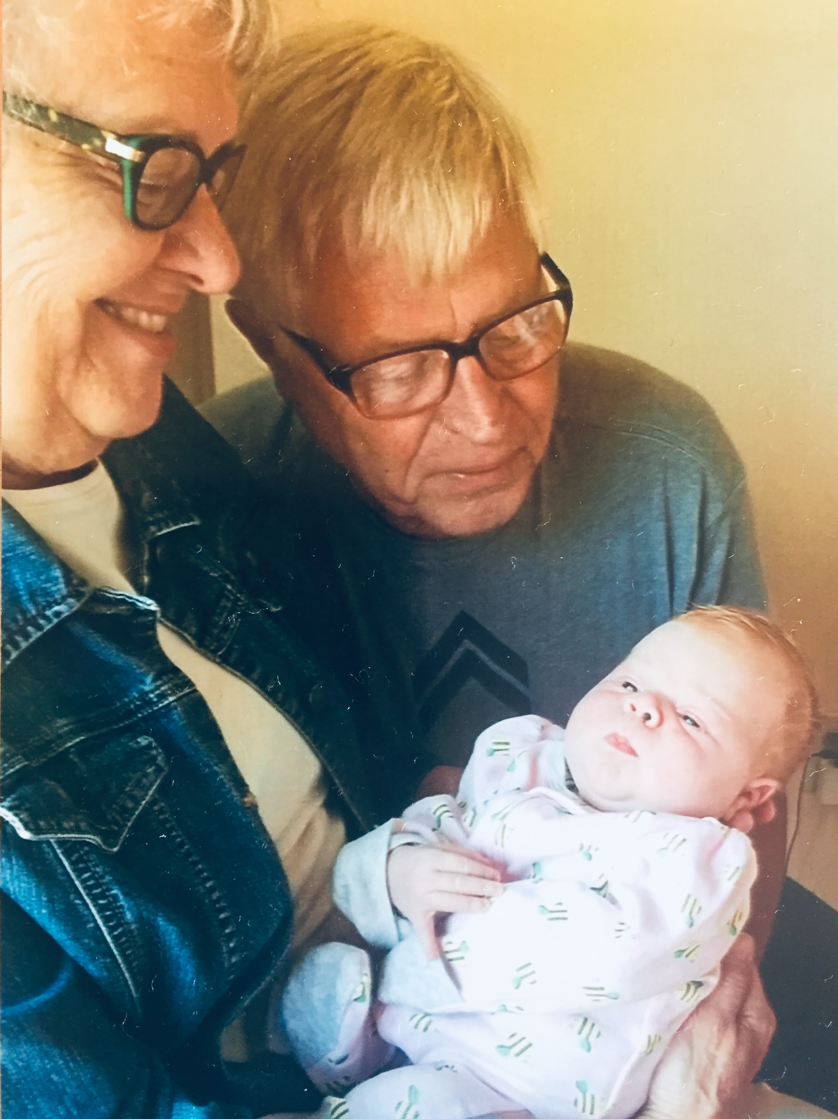
Jim and Carmen Tisher also celebrated the baptism of their new grandchild, Hannah Anne Tisher, born Aug 3, 2019 to Stephanie & Kirk Tisher, on November 3rd at the Church of the Cross, Hopkins, MN.


PWC Hope Circle will meet on Wednesday, January 8th, at 2:00 p.m. All women of the church are invited to attend.

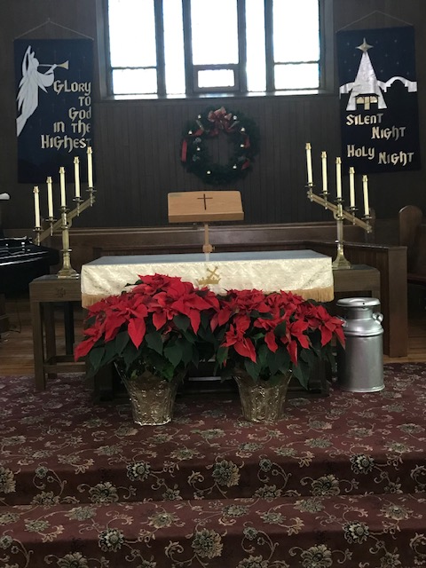
Peace to All . . .

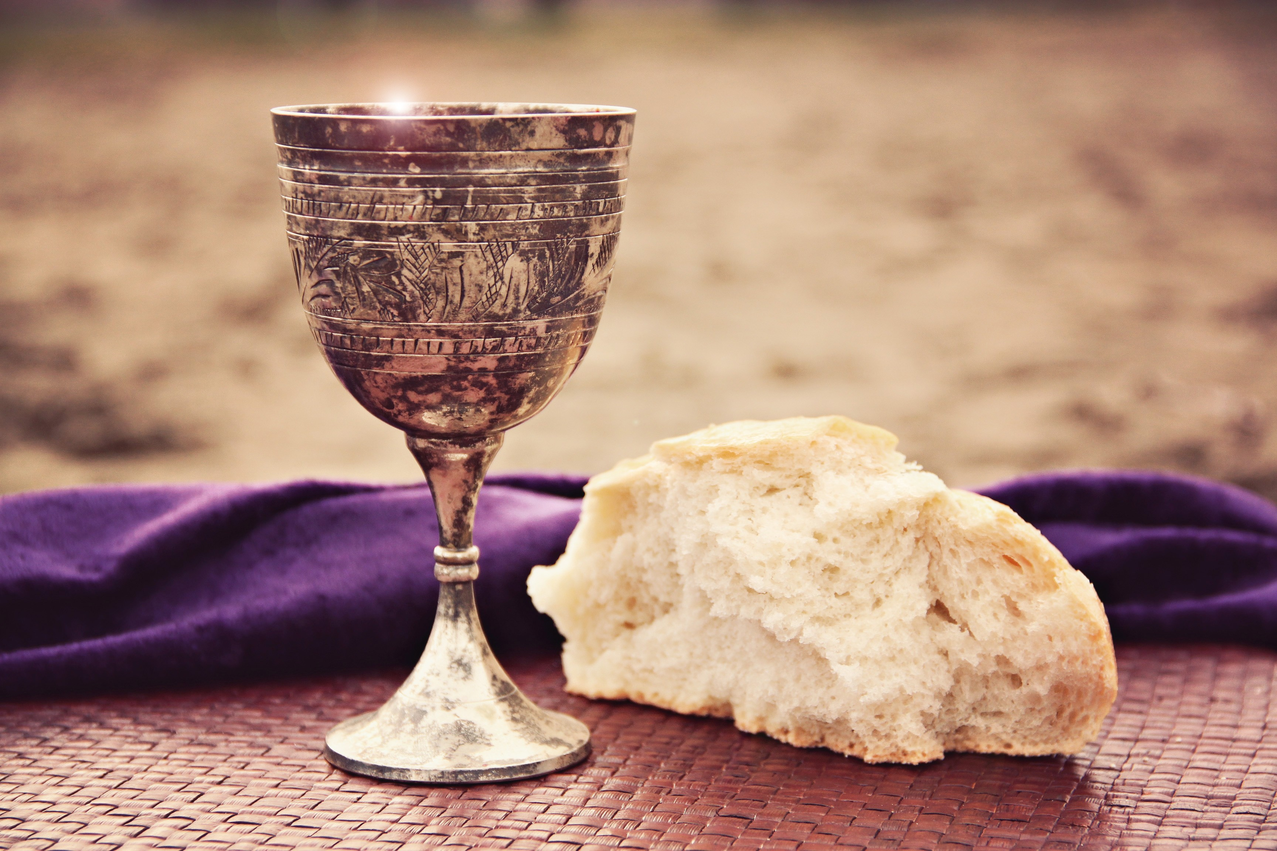
We will be having communion on Sunday, January 5th, 2020.

The church’s
ANNUAL MEETING
will be January 19th

New Website
COMING SOON!!!


Our New Website should be up and running in January and will be available to everyone at:
fpcbritton.com


First Presbyterian Church
804 5th Street, Box 127, Phone: 605.448.2460
Pastor Donald Buck, 605.551.9001

